[INSERT YOUR LOGO OR NAME]

Clothing drive
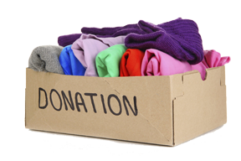
Please drop off your gently-used clothing (sizes 0 to 2X adult) or gently-used shoes (all sizes).

Date:
Time:
Location:
For more information contact:

Donations will go to Children in Need, Inc. which provides essential clothing, personal care, and educational supplies to all Washington County children in need.
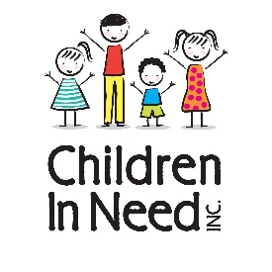
Every child enrolled in Washington County Public Schools who meets the “Free And Reduced Meals” criteria or attends Head Start of Washington County is eligible for services.
CIN’s primary mission is to keep children in school learning with a good sense of belonging in order that they may learn, grow and become productive citizens.

www.ChildrenInNeedWashingtonCounty.org

